**EE3070 Technical Training Report**

Important Note: Copying another person's work (even partially) is considered academic dishonesty, and the case will be reported to the University. It may result in disciplinary action against the involved students, including both the one who copied and the original writer.

|  |
| --- |
| **Submission Instructions**   1. The Team Leader must submit the group report via CANVAS Assignment. 2. File format:    * Report in pdf; Filename: TTR-Lx-GPy-SID.pdf  * Lx: lab session number of Team Leader (LB1, LB2, LC1 or L01) * GPy: group number * SID: Team Leader Student ID)   + Program codes for Training I and II attached as appendix.  1. Deadline for submission: Week 7 (before your lab section)    * Students in LB1, LB2 and LC1 (Monday): 3pm on 4th March 2024    * Students in L01 (Tuesday): 11:59am on 5th March 2024   **No late submission will be accepted. Please stay ALERT on CANVAS for any changes however unlikely on updates on submission deadlines.** |

Group No: L02 Gp 3

|  |  |
| --- | --- |
| Student Name | Student ID |
| Team leader: YIP Nim Kong | 57153709 |
| Team Member 1: HE Ka Hung | 57824104 |
| Team member 2: ZHENG Tsz Hin | 57846378 |
| Team member 3: CHAN Cheuk Long | 57206560 |

**30/01/2024/WSC**

**I. Arduino Programming (Based on Technical Training I)**

**Task 1.1 (Answer the 10 questions given in the manual)**

|  |  |
| --- | --- |
| Questions | Your answers |
| 1. What is the operating voltage of Mega 2560 ver 3? | 5V. |
| 1. In maximum, how many digital I/O pins you can assign in Mega 2560 ver 3? | 54 digital I/O pins can assign in Mega 2560 ver 3. |
| 1. Which I/O pins can provide PWM output (give the pin numbers)? | 2 to 13, 44 to 46 pins can provide PWM output. |
| 1. What is the smallest non-zero average voltage that PWM output can provide? | 5V / 256 = 0.01953V. |
| 1. How many pins can be used to read a sensor for which its output is ranged from 0V to 3V? | 16 analog pins (A0-A15) |
| 1. Can we use an I/O pin to directly light up a LED if it needs 2V and 10mA (without using any driving circuit)? | Yes. |
| 1. If you use your Arduino board to read an analog input, what is the possible largest digital value you obtained? | 1023. |
| 1. How many serial communication pairs that Mega 2560 has? | 4. |
| 1. In maximum, how many bytes you can use for your program code? | 258048 bytes. |
| 1. List all the pins that support external interrupts? | D2, D3, D21, D20, D19, D18 |

**Task 1.2**

**Answer questions to get familiar with pin assignment for communications.**

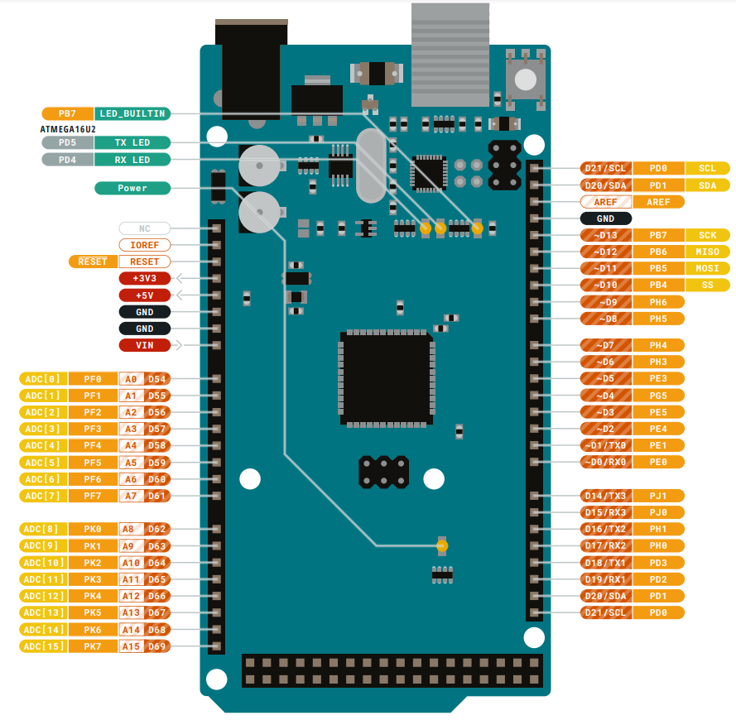



This project will make use of different types of serial communications, namely UART, I2C, and SPI. Please refer to the lecture notes for more information.

1. There are four default UART serial communications. One of them is also used for the Serial monitor. Therefore, do not use that serial if you are using the Serial monitor.Circle the transmitter and receiver pins for that serial port and mark it as UART.
2. I2C communications require 2 pins: one for the clock (SCL) and one for the data (SDA). Circle the default pins assigned for these functions and mark them as I2C.
3. SPI communications use 4 pins: clock (SCK), slave select (SS), master-input-slave-output (MISO), and master-output-slave-input (MOSI). Circle the default pins assigned for these functions and mark them as SPI.

**Task 2 Get Familiar with the project platform**

**Task 2.1**

|  |  |
| --- | --- |
| Modules | The name of the module |
| A | Pressure sensor |
| B | Temperature sensor |
| C | Wi-Fi module |
| D | RGB LED |
| E | RFID Reader |
| F | Relay |
| G | OLED display |
| H | Ultrasonic sensor |
| I | E-Paper |
| J | DC/DC converter |

**Task 2.2**

Explain how the driving circuit works to turn D2 on and off

|  |
| --- |
| * **Transistor Operation**:   + The transistor Q1 is used as a switch. When a control signal from U1 is applied to the base of Q1, it allows current to flow from the collector to the emitter.   + The base-emitter voltage Vbe*Vbe*​ controls the transistor's switching. * **LED Control**:   + The RGB LED has a common anode, meaning all three LEDs share a common positive connection. The individual cathodes are connected to the collector of Q1 through the resistor R1.   + When Q1 is turned on, current flows through R1 and the selected LED(s), causing them to light up. The specific LEDs that light up depend on which of D1, D2, or D3 are connected to the circuit. * **Resistors**:   + **Rb** ensures the base current is sufficient to switch the transistor without drawing too much current from U1.   + **R1** limits the current through the LEDs to prevent damage. |

**Task 3. Programming Tasks**

**Task 3A: Display color with RGB LED**

1. Provide your connection (in simple block diagram)

Arduino

B.LED Input

G.LED Input

R.LED Input

Transistor driving circuit

RGB LED

Jumper box



1. Draw flow chart of your program

1. Provide your program list

|  |
| --- |
|  |

**Task 3B.**

1. Give a description on your function mapping
2. Give your program listing

**Task 3C:**

1. Give a description on your function mapping
2. Provide your program listing

**II. Design Module (Based on Technical Training II)**

Technical Training II: Topic _____ (Input the topic number)

**II.A Design Task 1.**

|  |
| --- |
| Section 1A. Task description   * Describe the task in your own words |
| Section 1B. Hardware settings   * Draw a block diagram about the connections and describe the hardware settings |
| Section 1C. Software design   * Put the program codes as appendix at the back of report, e.g. Appendix: Task 1 Code. * State at least 3 key points for the design, and explain why they are important (e.g. how you set the pins in software to match with hardware; how to control the I/O; how to set the parameters; … ) |

**II.B Design Task 2.**

|  |
| --- |
| Section 2A. Task description   * Describe the task in your own words |
| Section 2B. Hardware settings   * Draw a block diagram about the connections and describe the hardware settings * Note: If the task has the same setup as before, you may just refer to the figure as given in your report. |
| Section 2C. Software design   * Put the program codes as appendix at the back of report, e.g. Appendix: Task 2 Code. * State at least 3 key points for the design, and explain why they are important (e.g. how you set the pins in software to match with hardware; how to control the I/O; how to set the parameters; …) |

**II.C Design Task 3.**

|  |
| --- |
| Section 3A. Task description   * Describe the task in your own words |
| Section 3B. Hardware settings   * Draw a block diagram about the connections and describe the hardware settings * Note: If the task has the same setup as before, you may just refer to the figure as given in your report. |
| Section 3C. Software design   * Put the program codes as appendix at the back of report, e.g. Appendix: Task 3 Code. * State at least 3 key points for the design, and explain why they are important (e.g. how you set the pins in software to match with hardware; how to control the I/O; how to set the parameters; …) |

**II.D Advance Design Task 1 (if you have attempted)**

|  |
| --- |
| Section 4A. Task description   * Describe the task in your own words |
| Section 4B. Hardware settings   * Draw a block diagram about the connections and describe the hardware settings * Note: If the task has the same setup as before, you may just refer to the figure as given in your report. |
| Section 4C. Software design and explanation   * Put the program codes as appendix at the back of report, e.g. Appendix: Task 4 Code. * Explain your design (how it can achieve the task) |

**[Add more sections if needed]**

**II.E Discussions**

* Answer the questions in the manual
* Briefly summarize what you learnt